a film by
CHRISTOPHER S. LOMBARDI

Directed by
CHRISTOPHER S. LOMBARDI

Starring
BRISTOL POMEROY
ELISE ROVINSKY
and
LOU D’AMATO

www.reluctantdetectivemovie.com
www.facebook.com/ReluctantDetectiveMovie

CL Productions, LLC
Chris Lombardi
T: 203-414-6217
bennettstephens@ymail.com
THE RELUCTANT DETECTIVE

Tagline:

He’s not a detective, he just plays one on TV.

Short Synopsis:

The Reluctant Detective revolves around Bennett Stephens, a well-known television actor on a popular Cable-TV crime show. While on vacation, Bennett gets entangled, with the insistence of his wife Kelly, in trying to solve a double homicide. Along the way Bennett meets many friends, foes and colorful characters. Bennett is assisted not only by his wife, but by his new friend Fish, a street wise but gentle hearted gangster, who is also visiting the town on vacation. Bennett must rise to the challenge of trying to crack the case!

Technical Information:

Running Time: 96 min.
Not yet rated by the MPAA
Camera: shot on Canon 5Dmkii and Sony NEX FS100
Editing System: Sony Vegas Pro
Color Correction: Blackmagic DaVinci Resolve
Sound Mix: Stereo (Embedded)
Performance Screening Format: MOV, DVD-R, BD-R, HDD
Long Synopsis:

All Bennett Stephens wanted to do was have a peaceful and restful vacation. Although he was visiting his wife’s small hometown, a town seemingly untouched by time, he still had a two week hiatus from his popular Cable-TV crime show, MO: Motus Operandi. The schedule is grueling, but it affords Bennett the luxuries that both he and his wife Kelly have grown accustomed to. Bennett’s number one priority was to make sure he had time to visit his friend vodka and get in a few rounds of golf. Right off the train, he meets Fish and Fingers. Fingers is an old high school acquaintance of Kelly’s, and he strikes up a conversation with them while incognito as a cab driver. The road weary couple is then introduced to Fish, Fingers’ friend who is going to jump in the car and rob them at gunpoint. Fish seems tough on the outside but has a heart of gold and takes an immediate liking to the couple. After meeting Bennett’s mother-in-law, Carol Shaw, we find that Bennett’s apprehension about the visit was well warranted especially since he found out the county is now a dry county. Bennett gets an invitation—via telegram to Nicky Sargenti’s club; the only club in town that serves liquor. Nicky is the kingpin in the town and is a very powerful and influential man within the county. During dinner, the club singer is murdered in her dressing room and Bennett is asked to take a look. There, Bennett meets the egocentric but dimwitted, Detective Henry (Hank) Forbes. Detective Forbes makes it clear in front of everyone that he doesn’t need help from a pathetic TV actor, and he doesn’t want Bennett weaseling in on his territory. Behind closed doors; however, Forbes pleads with Bennett to help on the case. After an attempt on Bennett’s life and a misprinted front page story about Bennett taking the lead on the case, Bennett reluctantly agrees to help with the investigation. As if Bennett did not have enough on his plate, he also meets Brad Truman, Kelly’s old high school boyfriend, who is also the mayor of the town. It seems that Kelly left a lot of suitors behind when she left the town. Brad wastes no time trying to rekindle their old flame. Kelly likes the attention since it isn’t easy being married to a famous television actor, and it’s never easy for her to take the back seat. During a very eventful golf game, the plot thickens when Kelly discovers a secret in the bushes, which not only adds to the body count, but also adds to the confusion of ever cracking the case. Kelly becomes a local hero of sorts and is to be interviewed about how she found the body and how Bennett is assisting with the case. After a lengthy interview by the newspaper reporter, Bennett gets bored and decides to review the case thus far with Detective Forbes. Bennett decides to throw a dinner party to get all the suspects together and get everything out in the open because as Fish suggests, “when you get everyone talking, someone’s bound to slip up.” After serving up course after hilarious course at dinner, it’s off to the living room for the real evening’s entertainment. Bennett has his sights on a murderer. In a devilishly clever ‘fish’ out of water story (no pun intended), Bennett must wrap up this homicide with a little help from his wife and new friend Fish.

THE RELUCTANT DETECTIVE

Meet the cast

Bristol Pomeroy as Bennett Stephens

Bristol is a NY based actor, Queens to be exact. His foundation is in theatre with an acting degree from S.U.N.Y. Purchase. Working mainly in Independent film as well some TV (The Americans), he’s very happy to have been involved with The Reluctant Detective and hopes there will be more opportunities for collaboration with Chris Lombardi and the cast.

Selected filmography: FAT (TIFF 2013), Marathon, 2 Sunny Days,
Terminal Legacy.
IMDB

Elise Rovinksy as Kelly Stephens

Elise is a graduate of the Stella Adler Conservatory of Acting. She has also studied drama at the University of Gothenburg in Sweden. She is living the life of a working actor in New York City. She has done many feature films, TV commercials and print ads, and most recently starred in Come Morning which premiered at the Austin Film Festival.

Selected Filmography: Come Morning, The Boyz of Summer, Fog Warning.

IMDB

Lou D’Amato as Fish

Lou cut his teeth in theatre many years ago in an off Broadway performance of Arthur Miller’s A View From the Bridge playing Eddie Carbone. Lou has been featured in many national TV shows and print ads. Lou has been very fortunate to study with Aaron Speiser and the 2 time Academy Award® nominee, Jill Clayburgh. After leaving the corporate world to focus on acting full time, Lou has been too busy to look back.

Selected filmography: The Level, Pizza Me, Mafia, The One Nighter,
Solidarity.
IMDB

Director’s Statement:

Having finally completed The Reluctant Detective leaves me with nothing but elation. It’s a typical story of a filmmaker with a vision and story to tell, but there is so much more to it. The script came very quickly; once I had the idea and the story fleshed out, I banged out the first draft in less than a month. With the urging of family and friends, I started to look into a way to get the film made. Everything fell into place. I found a DP that understood the style and look I was going for. I found amazing actors and a great crew that were willing to help me on this cathartic journey.

I was lucky to have some really great locations. We shot at the same train station that Alfred Hitchcock shot scenes of Strangers on a Train. I convinced my town to let me shoot on their golf course. I also convinced my 80 year old grandfather to let me take over his house for 3 weeks to use as the main location. I was blessed that he let us do that because I couldn’t imagine shooting the house scenes anywhere else.

As much as I wasn’t trying to make a 1940’s film in the present time, there are certain elements that harken back to those days. Some elements include the pattern of speech, the props, wardrobe and also the credit sequence. I think that the public will notice all the little touches that went into making this film look and feel like a vintage screwball comedy.

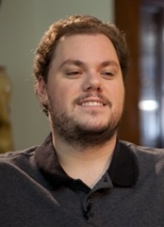
Christopher S. Lombardi (Director, Writer, Producer)
Chris first became interested in filmmaking at the age of 10 when his family got their first video camera. "I started making narrative movies, doing editing in the camera as we shot, by hitting ‘stop’ and switching to a different angle and hitting ‘start’ again." This childhood fascination has manifested itself into a real calling for the director who envisions a future for his characters from The Reluctant Detective. After college, he worked on a few Indies to gain the experience and know-how to make his own film. Backed by his family and a few close friends, cameras started rolling and everything seemed to fall into place. "I couldn't be happier with the cast and have so many fond memories of creating this film. I would love to turn this into a set of movies where Bennett (Bristol Pomeroy), Kelly (Elise Rovinsky), and Fish (Lou D'Amato) solve mysteries." Chris also has a fascination with analog photography (using film). He shoots many vintage formats including 8mm movie film, 110, 620 and Instant film. He also has an affinity for black & white film, and even develops it himself. Chris is also an accomplished guitar player, and has been playing since he was eight years old, and owns many stringed instruments.

IMDB

Question & Answer with the Director, Christopher S. Lombardi
Q: What was your inspiration for The Reluctant Detective?
A: I wanted to recreate all those wonderful classic films from the 30’s and 40’s, but I wanted to add my spin to them. I worked with the wonderfully talented Elise Rovinsky (Kelly Stephens) on an indie feature shot in Connecticut. We clicked immediately and one day during lunch I told her I was going to write her a film. Three years later I delivered on that promise. Elise has such classic features and her beauty is reminiscent of old starlets from the 1930’s. I love mixed genre films, so I tried to mix screwball comedy and detective mystery with shades of Film Noir. The film takes place in current time, but the town seems to be frozen in time. I worked really hard to craft the dialog to make it feel reminiscent of another era.

Q: What were some of your biggest challenges putting this idea on screen?
A: I dealt with most of the things that indie filmmakers deal with. I found shooting in Connecticut as a reward instead of a challenge. We are very close to New York, so finding crew and cast was not an issue. In fact, more than half of the cast and crew are from Connecticut. It took a lot of hard work, but I couldn’t be happier with the outcome and we got a lot of great production value. I had help from many places. My old college advisor (Liz Popiel) plays the mother-in-law. She is an Emmy® Award winning set designer—turned actor, for my film.

Q: What was appealing about the style to you that you that you wanted to create a modern film about it?
A: There is just a wonderful style and elegance to old films. At first the cast had a difficult time discerning when the film took place. After I explained the premise to them, they understood it and did anything and everything I asked. The town still has telegrams, everyone wears suits and fedoras and there are rotary telephones. That look was very appealing to me. The other thing that looked appealing to me was all the stained wood at the main location. You don’t really see that now-a-days. All the actors worked hard to make their characters come to life. One of the best compliments I got on the script was from the actor who played Forbes (Gideon Fountain). After I sent him the script, he told me that it ‘read like an old 1930’s screwball romp.’ I was flattered, and with good reason too, Gideon comes from Hollywood royalty. His grandparents were silent film stars (John Gilbert & Leatrice Joy).

Q: What is your favorite scene?
A: That’s a tough question, every scene is my favorite. I can narrow it down to two. The first one would be what is affectionately call ‘the hat scene.’ Elise is brilliant in it. Her comic timing and delivery takes a serious scene and softens it with physical comedy. The other scene is when Bennett is reviewing the facts of the case in Forbes’ office. Fish is doing some amazing comedy bits that can only get better with repeat viewings.
Publicity Stills
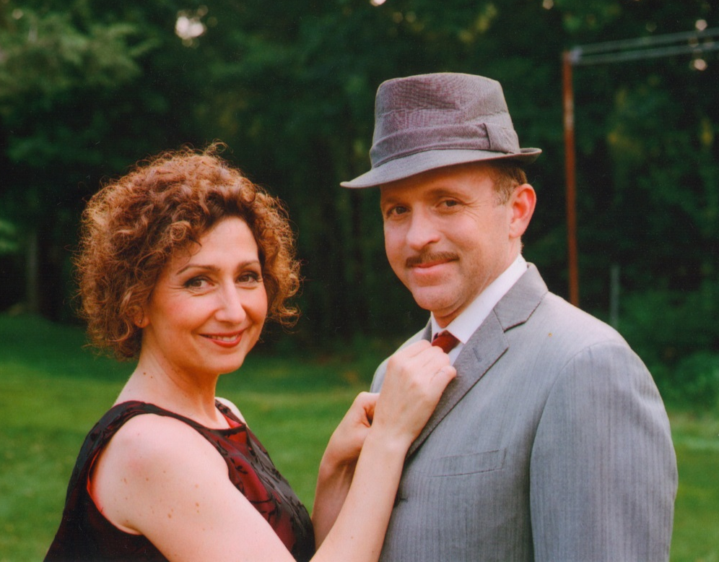
Elise Rovinsky as Kelly Stephens and Bristol Pomeroy as Bennett Stephens

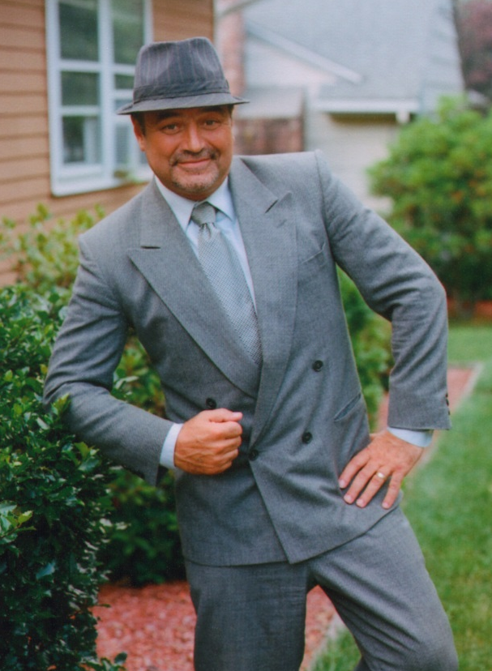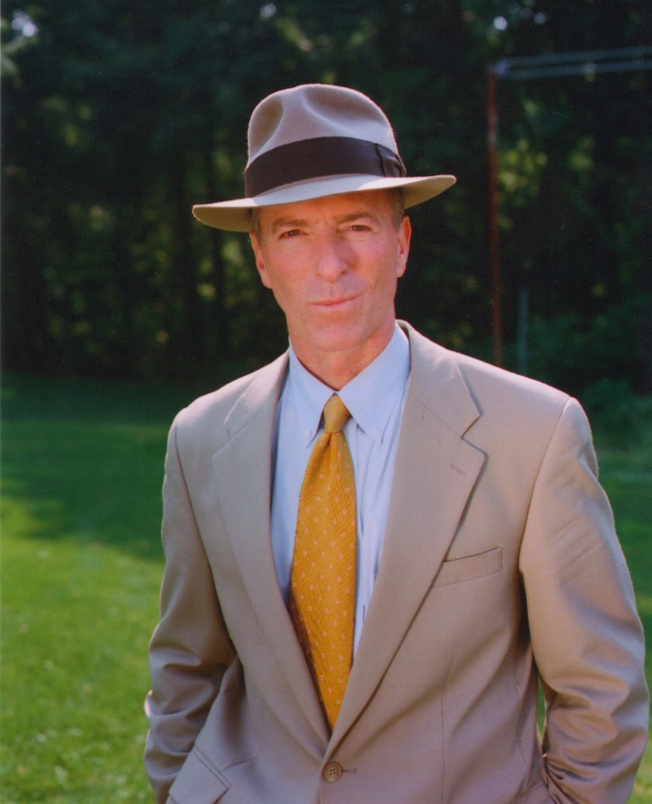
Lou D’Amato as Fish Gideon Fountain as Det. Forbes

Behind the Scenes of The Reluctant Detective
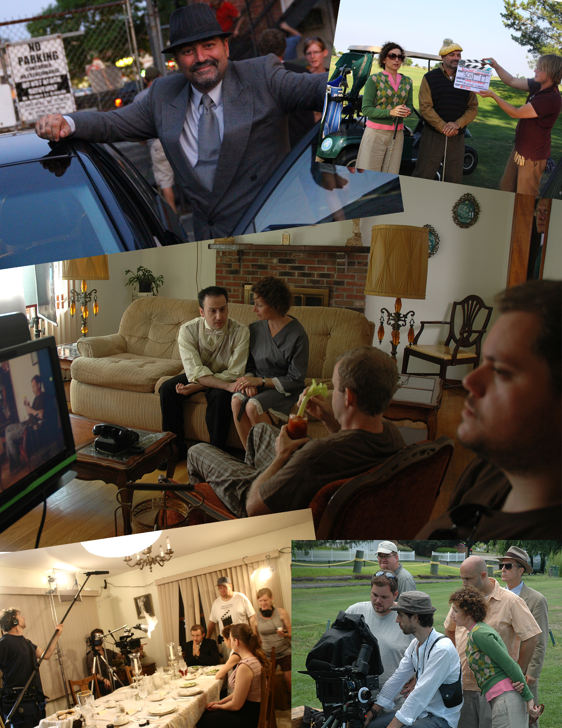
Production Stills
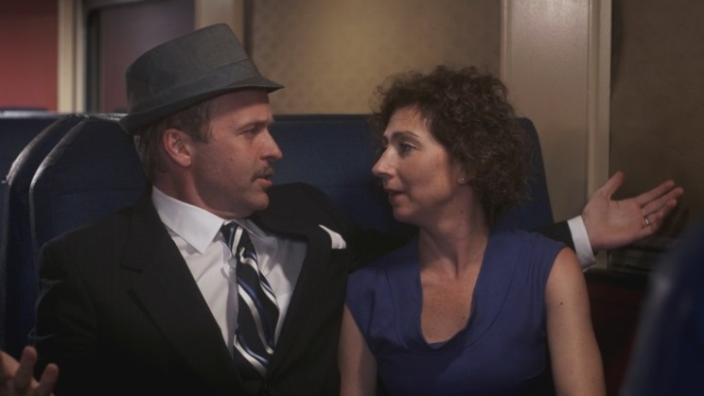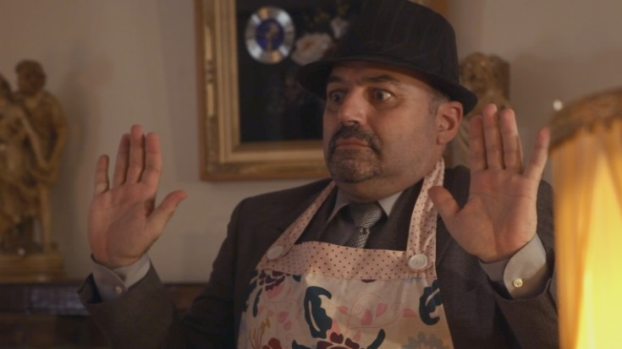
Bennett and Kelly Fish

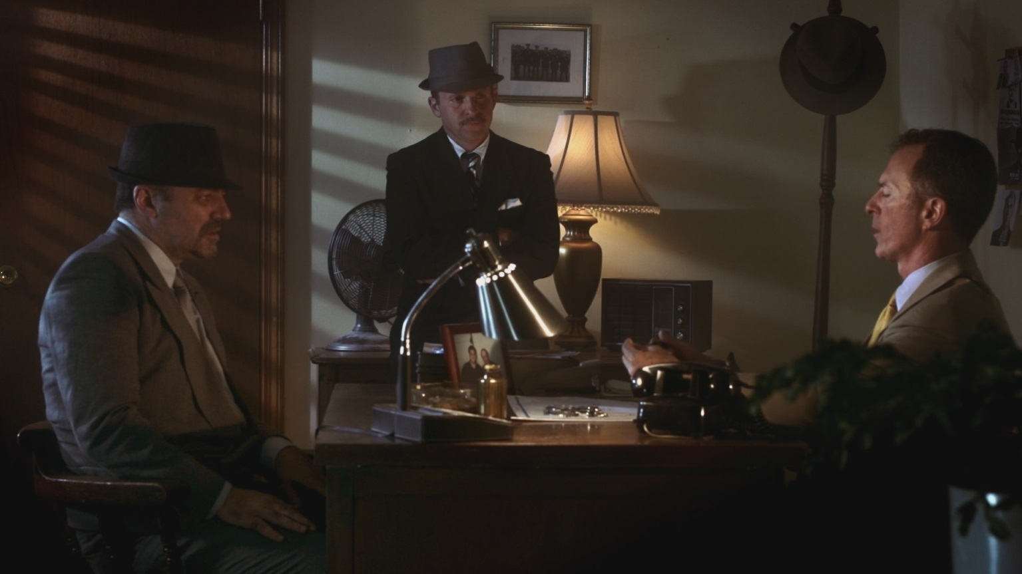
Fish, Bennett and Det. Forbes

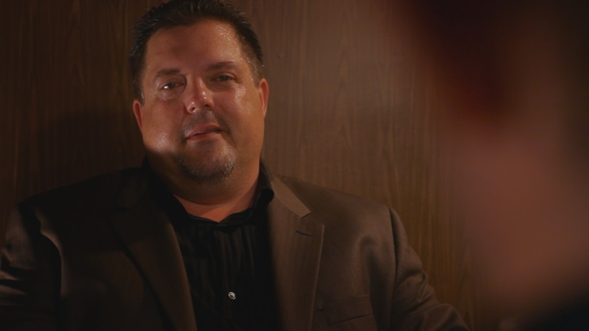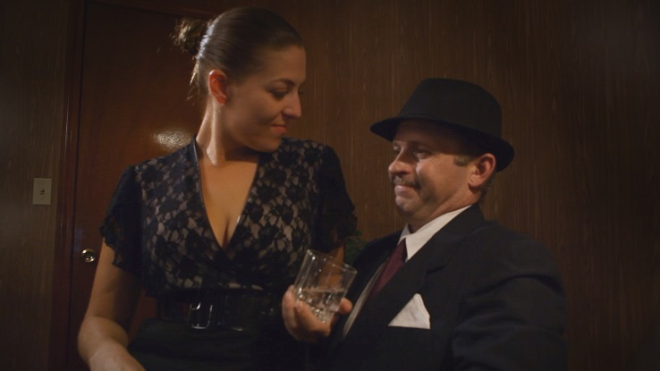
Nicky Sargenti Charmaine and Bennett

CL Productions Presents

a film by
Christopher S. Lombardi

Directed by Christopher S. Lombardi

Bennett Stephens. . . . . . . . . . . . . . . . . . . . . . .Bristol Pomeroy
Kelly Stephens. . . . . . . . . . . . . . . . . . . . . . . . . .Elise Rovinksy
Fish . . . . . . . . . . . . . . . . . . . . . . . . . . . . . . . . . . .Lou D’Amato
Det. Henry Forbes. . . . . . . . . . . . . . . . . . . . . .Gideon Fountain
Fingers. . . . . . . . . . . . . . . . . . . . . . . . . . . . . . . . . .Chris Skeries
Brad Truman. . . . . . . . . . . . . . . . . . . . . . . . . . . . .Peter A. Luna
Nicky Sargenti. . . . . . . . . . . . . . . . . . . . . . . . . . . .Joe Nemchek
Charmaine Michaels. . . . . . . . . . . . . . . . . . . . . . . .Cecilia Ryan
Tommy Thompson. . . . . . . . . . . . . . . . . . . . . . . . . Bijhan Clarke
Reporter. . . . . . . . . . . . . . . . . . . . . . . . . . . . . . .Patrick B. White
Tiny. . . . . . . . . . . . . . . . . . . . . . . . . . . . . . . .Christopher Annino
Waiter. . . . . . . . . . . . . . . . . . . . . . . . . . . . . . . . . . . . .Chris Vater
Newspaper Secretary . . . . . . . . . . . . . . . . . . . . . .Jaki V. Lauper
Train Conductor. . . . . . . . . . . . . . . . . . . . . . . . . . . .John Noonan
Woman on Train. . . . . . . . . . . . . . . . . . . . . . . . . Joann Lombardi
and
Carol. . . . . . . . . . . . . . . . . . . . . . . . . . . . . . . . . .Elizabeth Popiel

Photographed by. . . . . . . . . . . . . . . . . . . . . Sung Rae Cho
Michael LaVoie
Chief Electricians. . . . . . . . . . . . . . . . . . . .Blaise L. Miller
Jordan Bell
Key Grip. . . . . . . . . . . . . . . . . . . . . . . . . . .Justin Amorusi
Grips. . . . . . . . . . . . . . . . . . . . . . . . . . . . Timothy E. Roth
Mike Magilnick
Sound. . . . . . . . . . . . . . . . . . . . . . . . . . . . . . . . .Nick Rosa
Assistant Camera. . . . . . . . . . . . . . . . . .Edward Charrette
Assistant Director. . . . . . . . . . . . . . . . . . Jason DeSimone
Art Director. . . . . . . . . . . . . . . . . . . . . . . . . . . . Austin Joy
Makeup Artist. . . . . . . . . . . . . . . . . . . . . . . . .Cheri Haller
Script Clerk. . . . . . . . . . . . . . . . . . . . . . .Aleesha Pinkham
Catering. . . . . . . . . . . . . . . . . . . . . . . . . . .Joann Lombardi
Costume Supervisor. . . . . . . . . . . . . . . . . .Gina M. Tonner
Casting. . . . . . . . . . . . . . . . . . . . . . . . . . . . .Erik E. Tonner
Production Assistance. . . . . . . . . . . . . . . .Cory Landroche
Ty Ebata
Elliot Severn
Sound Designer. . . . . . . . . . . . . . . . . . . . . . . .Ron Belanger
Musical Supervisor. . . . . . . . . . . . . . . . . . . . . . . .Austin Joy
Post Production Supervisor. . . . . . . . . . . . . Mike Magilnick
Re-Recording. . . . . . . . . . . . . . . . . . . . . . . . . .Ron Belanger
Color Timing. . . . . . . . . . . . . . . . . . . . . . . . .Patrick Inhofer
Online Editor. . . . . . . . . . . . . . . . . . . . . . . . Mike Magilnick
Editor. . . . . . . . . . . . . . . . . . . . . . .Christopher S. Lombardi
Associate Producer. . . . . . . . . . . . . . . . . . . . .Erik E. Tonner

The Producers would like to thank…
Town of Stratford, Conn.
Danbury Railway Museum
and
Domenico Lombardi

Written by
Christopher S. Lombardi

Produced by
Christopher S. Lombardi
&
Mariette F. Lange

This is a work of fiction. Names, characters, places and incidents either are products of the author’s imagination or are used fictitiously. Any resemblance to actual events or locales or persons, living or dead, is entirely coincidental.

Copyright 2013 CL Productions, LLC

