

FRIEL FILMS
269-207-5069

Press Release

For Immediate Release
Press Contact:
Steve Thompson
Thompson Communications
856-942-4434
steve@thomcomm.net

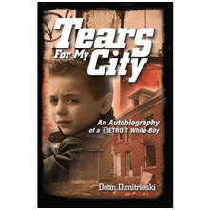
Friel Films Options Dean Dimitrieski’s “Tears for My City: An Autobiography of a Detroit White Boy”

Detroit, MI – August, 2014 -- Dean Dimitrieski’s Tears for My City: An Autobiography of a Detroit White Boy is the powerful true story of a Macedonian boy whose family moves into Detroit’s most dangerous neighborhood when gang violence was at its peak during the seventies.

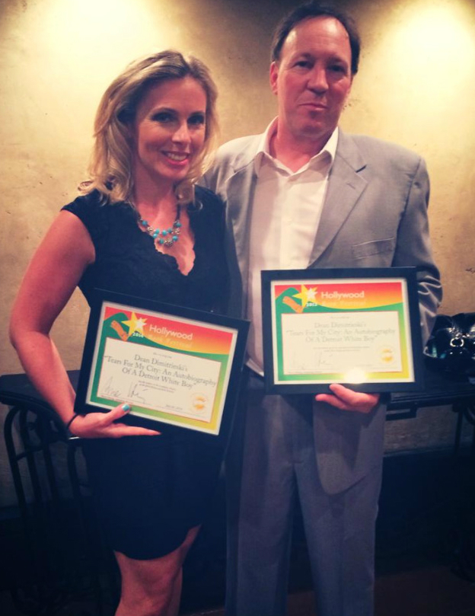
The well received book was recently honored in the Autobiography category, and received the Best Screenplay award at the Hollywood Book Festival Awards ceremony, which took place Saturday July 26, at the Hollywood Roosevelt Hotel, the home of the first Academy Awards. The awards were accepted by the author’s wife Val Dimitrieski.
Val Dimitrieski
and Phil Wurtzel
with the Hollywood Film Festival Awards

On optioning Dean’s book, Phil Wurtzel, producer with Friel Films comments: “I met Dean a little over two years ago when he came to me through a mutual friend for some advice on a deal/option he was going to sign with another producer. I was able to help him, then a couple of months later when things had fallen apart with that producer, he wanted me to take on this project. I agreed.

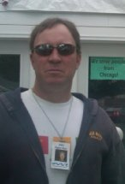
What compelled me to option the book was the fact that growing up in the seventies my family went into Detroit often to my uncle's home for the weekend, and I knew the streets/areas that Dean described. I saw the Detroit that still had homeowners living in tidy little brick homes and had very little of the deterioration you see now. My Uncle and Aunt passed away in the early eighties, just as the drug trade exploded, and literally within four to five years, those tidy homes were either abandoned or set on fire. Those that weren't had the owners fighting for their lives against the drugs and gangs. This story really appeals to me on that personal level.”
Friel Films Producer
Phil Wurtzel

Producer Wurtzel further explains: “This story’s appeal is really everyman’s story of the struggle to build a better life for ourselves and our families, told through Dean and his family’s personal true story: Immigrants looking for a better life, arriving in America from war-torn Macedonia, and the problems they faced once they landed in Detroit during the crack cocaine wave.”

Film to Offer Hope to Inner City Young People

Phil wants to leave the audience, particularly young people, with the message that for people who live in a bad neighborhood and want to leave, there are opportunities available, like grants to get into a college or a trade school, showing that it is possible to get a better outlook on life, and created a better future for yourself, the same way Dean did.

The film will be shot as close as possible to the actual locations in Detroit where Dean’s story takes place, because we want the visuals to speak with authenticity to the people who most need the message of hope for a better life.

Phil is currently working on enlisting the cooperation of those groups who are active in improving the lives of inner city young people, so the film will genuinely speak to, and actually become a resource for those young people.

Friel Films has two other projects in post-production: Cawdor, a tense tale of psychological terror, with Cary Elwes, and The Barn Theatre: Tomorrow's Stars Today, with Lauren Graham and Jennifer Garner.

# # # #

About Producer Phil Wurtzel / Friel Films

In the early nineties in Los Angeles Phil was an apprentice at Theatre West. He watched an unknown actor by the name of Chazz Palminteri create The Bronx Tale script from just a five minute monologue talking about growing up in a mob infested neighborhood. Phil felt the same passion and electricity reading Dean’s story, knowing that Dean chose the better path in life, as did Chazz.

Phil Wurtzel, Friel Films is available for interview by appointment.

Contact:
Steve Thompson
Thompson Communications
856-942-4434
steve@thomcomm.net

Hollywood Book Festival
www.hollywoodbookfestival.com

Cawdor on IMDb
www.imdb.com/title/tt3268790/

More news coming soon on
The Barn Theatre: Tomorrow’s Stars Today

