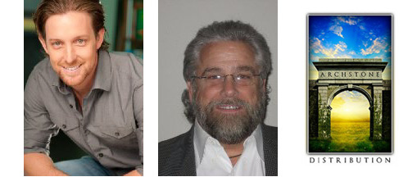
Scott Martin Michael Slifkin

Scott Martin and Michael Slifkin
of Archstone Distribution

PRESS RELEASE

For Immediate Release
Press Contact:
Steve Thompson
Thompson Communications
856-942-4434
steve@thomcomm.net

SCOTT MARTIN, MICHAEL SLIFKIN,
AND THE INSIDE STORY OF ARCHSTONE DISTRIBUTION

June 2014 -- Los Angeles, CA – Although international sales agent and distributor Archstone Distribution offered the foreign rights to Gutshot Straight starring George Eads, AnnaLynne McCord, Steven Seagal, Vinnie Jones and more, at the recent Cannes Film Market, and sold it into a dozen foreign territories, their story neither begins nor ends there.

Scott Martin and Michael Slifkin are the founding partners of Archstone Distribution. They began with Archstone Pictures producing films, but soon realizing the importance of distribution, were joined by Braden Bowen, who now focuses on distribution and runs the company's day to day operations.

Along with their distribution company, Scott and Michael continue to be very actively involved in every aspect of filmmaking through Archstone Pictures, with multiple films in development and various stages of production.

Iceland, Settle the Score with a .44, Slay Ride, and Paradise Burning are in development. Awaken, Out of the Burning Blue, and P-51 Dragon Fighter are in production.

Scott Martin is also an actor, writer, director, and producer. He will be a guest of honor at the Producers Network at the upcoming Marche du Film in Cannes. Scott is the director of Slay Ride, and will appear onscreen as Lt. John Robbins, the lead in P-51 Dragon Fighter.

Michael Slifkin is producing all seven projects!

Scott Martin notes: “I’m excited to be in the position we are in, with three films in production and several in development. We have worked very hard to get to this point, and we’re looking forward to adding more projects to our slate in the near future.”

Archstone Distribution recently sold the foreign rights into a dozen territories for the crime action thriller Gutshot Straight at the recent Cannes Film Market. Directed by Justin Steele, Gutshot Straight stars George Eads (CSI: Crime Scene Investigation), AnnaLynne McCord (90210, Excision), Steven Seagal (Above the Law, Under Siege), Vinnie Jones (Snatch; Lock, Stock and Two Smoking Barrels), Stephen Lang (Avatar), Ted Levine (Monk, Shudder Island), and Tia Carrere (True Lies, Lilo & Stitch).

Known and respected as a filmmaker friendly company, Archstone adheres to a policy of open-book accounting and transparency where producers have 100% approval of all marketing expenses and sales deals made in the worldwide marketplace.
They will continue to work with a growing family of filmmakers, delivering their visions to the world!
# # # #

Scott Martin and Michael Slifkin
Founding Partners of Archstone Distribution
are available for interview.

Please Contact Steve Thompson
Thompson Communications
856-942-4434

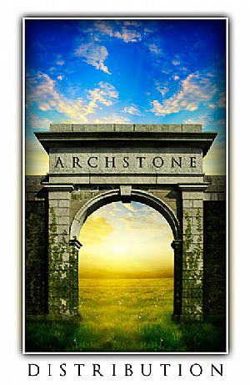

Archstone Distribution
1201 W. 5th Street; Suite T-420, 4th Floor; Los Angeles, CA 90017
310.622.8773

www.archstonedistribution.com

Scott Martin, Michael Slifkin, and the Inside Story of Archstone Distribution, Continued


Scott Martin is a talented filmmaker and producer. He is a Partner and Founder of both Archstone Distribution and Archstone Pictures. Scott is currently writing, directing, and producing feature film content for world wide distribution and recently completed directing and starring in Battle Force a period feature film currently being distributed world-wide as well as starring in P-51 Dragon Fighter, which comes out later this summer.

Prior to his involvement with Archstone Distribution, Scott worked with several production and development companies including a stint for a production company on the Paramount Lot.

Scott's work includes Actor and Producer of P-51 Dragon Fighter a Sci-Fi/Action film set in North Africa during World War II and is set for release in late summer of this year. He was the Writer/Director and Actor in Battle Force a 1942 period film about the First Special Forces Unit and their pre-invasion of Sicily. Scott also is slated to direct and produce Slay Ride, an action/comedy/horror film later this year. Previously, Scott wrote and appeared alongside William Forsythe and Art Lafleur in the creature feature, The Rig.

Scott is getting married soon!

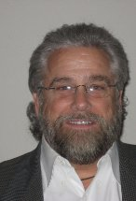
Michel Slifkin - Founder and Partner of Archstone Distribution and Archstone Pictures, Mr. Slifkin combines his extensive business and creative expertise with more than twenty-five years of professional experience in film, television and entertainment related industries. His background includes extensive experience in physical production, project financing, project acquisition, contract preparation and negotiations, budget preparation and supervision, project development/packaging, management and supervision, business management, and the development of numerous corporate strategic alliances and business ventures.
Mr. Slifkin’s creative background includes writer, producer, line-producer, director and production management as well as a thorough understanding of all aspects of production from concept through completion and on through sales, marketing and distribution of completed content to the world-wide audience.
Recent productions include: Battle Force – Producer/Line Producer. Distributed by Archstone Distribution, the film recouped the budget and realized a significant profit within the first six months. P-51 Dragon Fighter – Producer/Line Producer. WWII action film. Distributed by Archstone Distribution, project was in profit after first three territory sales. Sales continue in Cannes, 2014, A Perfect Vacation - Producer – Recently wrapped production. Distribution by Archstone Distribution. Selling in Cannes 2014. Out of the Burning Blue – Producer. Completed April 2014. Distribution by Archstone Distribution, Selling in Cannes 2014. Kickback – Producer. Production to begin summer 2014, and Slay Ride – Producer/Line Producer with production scheduled to begin in the fall of 2014.

Iceland
Scott Martin - “I can’t wait to make Iceland. I won’t give away the plot right now, but I can tell you it is an action adventure and the kind of movie I would love to see. The lead character is a dream role for me.”

Settle the Score with a .44
Michael Slifkin – “Settle the Score is an action buddy film set in the old west. Bad guys, good guys, some great comedy and a lot of fun.”

Slay Ride
Scott Martin - “Slay Ride is one of those fun little films that has the potential to really catch on with an audience. It’s the kind of thing that should play every year. Its pure entertainment.”

Paradise Burning
Michael Slifkin – “Set in a tropical paradise, this is one of those cool action/adventure films with heart and great characters. We are very excited about this project and another opportunity to make a film in a beautiful yet challenging location”

Awaken
Michael Slifkin – “What a cast we have in this film! Amazing experience to work with so many talented and gifted actors all on one project. The film uses a mix of great locations a strong story line and high production value to bring it all to life.”

Out of the Burning Blue
Scott Martin - “Out of the Burning Blue, visually, is a stunningly beautiful movie.”

P-51 Dragon Fighter
Scott Martin - “What can I say? Its Nazi dragons against P-51 Mustangs, and it delivers exactly what you think it will.”

Scott Martin - “In the next few years, I see us really ramping up our production slate to go along with the distribution company. Right now we are doing 3-5 a year, I would like to add a few larger films into that. The issue becomes quality control, but we have some very talented people working with us so we feel confident we can increase our production without sacrificing quality.”

# # # #

