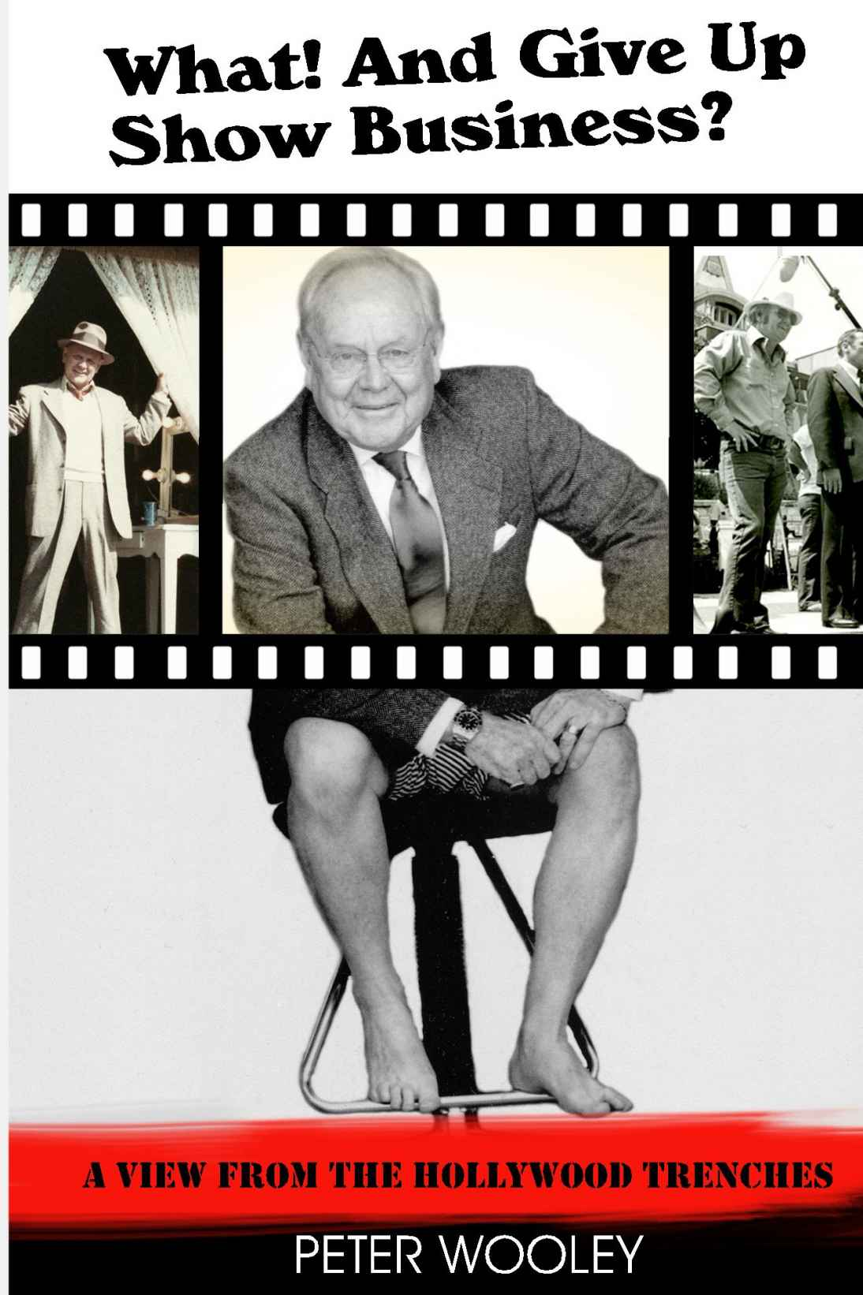

Peter Wooley
PRESS RELEASE
For Immediate Release

Press Contact:
Steve Thompson
Thompson Communications
856-942-4434
steve@thomcomm.net

AUTHOR / PRODUCTION DESIGNER / PRODUCER
PETER WOOLEY’S “WHAT! AND GIVE UP SHOW BUSINESS? A VIEW
FROM THE HOLLYWOOD TRENCHES”
UPDATED, SECOND EDITION PUBLISHED, FOUR NEW CHAPTERS ADDED

August, 2014 -- Los Angeles, CA – There are many books considered essential on the art, business, and technical sides of filmmaking. Peter Wooley’s What! And Give Up Show Business? A View from the Hollywood Trenches is essential reading for anyone interested in the personal (and many times humorous) side of filmmaking.

Peter Wooley is one of Hollywood's top production designers with 55 IMDb Production Designer credits including Mel Brooks’ Blazing Saddles and High Anxiety; Oh, God! You Devil; Under the Rainbow and many, many more. The updated edition, with four new chapters added, are Peter’s fascinating and sometimes hilarious reminiscences which include:
* Robert Mitchum falling off a barstool
* Brian Keith's creative, incessant swearing
* The fate of the fake bird droppings on the set of Mel Brooks' High Anxiety.
From Katharine Hepburn to Danny Thomas to Robert Redford to Dolly Parton to Don King, and even Billie Barty -- Wooley's met them all, watched them all, and tells all!
And his memories are not just about stars, but also about the scores of creative, clever, zany, egotistical characters he's worked with in his demanding and creative profession. Full of fun and gossip and yarns, Peter’s stories will take you from Hollywood, to Africa, to Greenville, North Carolina, and back! It's for everyone who wants to know what really goes on behind the scenes.

Peter Wooley is also the author of the recently completed You Only Go ‘Round Once which is the highly engaging story of three mens’ 50 year friendship. Now available on Amazon.

He is also a producer of Hybrids, starring Paul Sorvino, and Carolyn Hennesey, which is now in post-production.

# # # #
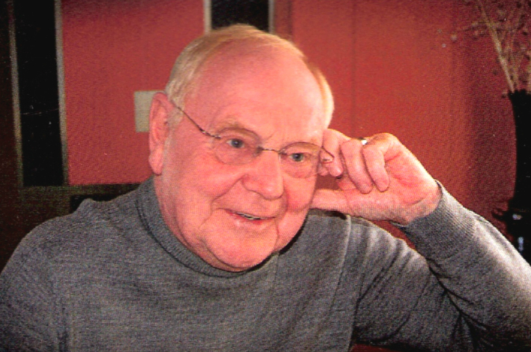
About Peter Wooley
When Peter Wooley was born, the world was in black and white. He came forth from a small town on the Ohio River determined to be the next Frank Lloyd Wright. Upon graduating from architectural school, he moved west to seek his fortune. Rather quickly he discovered he was not “doing” enough, not “designing” enough. More perspiration than inspiration.

That’s when the trouble started. He got involved with movie people. Before he knew it, he had thrown away his childish dreams and was searching the back alleys of Hollywood to find a way into show business. A dirty, steel-clad door with a barely readable sign, “Warner Bros.” screeched open, and a filthy arm reached out and yanked him out of that alley and into the arms of show business. Peter Wooley has not been seen since.

However his work has been seen and even admired from time to time. After forty years of being a production designer (a movie architect), he directed a bit, acted a bit, and produced a bit. He won an Emmy nomination for his design of the television movie The Day After.

What! And Give Up Show Business? Is Peter’s first book, originally published in 2002. It is a compendium of events that he witnessed, and often took part in during his career, and is now being readied for a second, updated publishing, with several new chapters. Luckily, he writes funnier than he designs.

You Only Go ‘Round Once is Peter’s recently completed novel, the highly engaging story of three mens’ fifty year friendship.

In 2007 he teamed with friend Tony Schweikle to produce a documentary, Barbarossa and the Towers of Italy, that won the international “Telly” Award. They are currently working on Hybrids, starring Paul Sorvino and Carolyn Hennesy which is currently in post-production, and five million, two hundred and twenty-seven other projects.

Author Peter Wooley is available for interview.

Please Contact Steve Thompson
Thompson Communications
856-942-4434
steve@thomcomm.net

Peter Wooley on IMDb
http://www.imdb.com/name/nm0941120/

What! and Give Up Show Business?: A View from the Hollywood Trenches
on Amazon

Peter Wooley is also a producer of Hybrids
Starring Paul Sorvino and Carolyn Hennesy
Press Information on Hybrids

