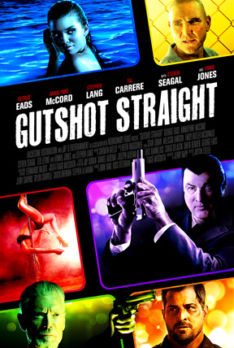

Archstone Distribution

PRESS RELEASE

For Immediate Release
Press Contact:
Steve Thompson
Thompson Communications
856-942-4434
steve@thomcomm.net

ARCHSTONE’S STRAIGHT FLUSH
“GUTSHOT STRAIGHT”
WITH GEORGE EADS, ANNALYNNE MCCORD AND STEVEN SEAGAL
BURNING UP CANNES MARKET

May 2014 -- Action is hot at the table in Cannes for Archstone Distribution with Gutshot Straight. So far, rights to the film have been sold for a dozen territories, and buyers are still getting into the game!
To date, Archstone has sold rights to Gutshot Straight to these territories / companies: UK - Solo; Japan - Prisidio; Middle East - Italia Film; Poland - Kino Swiat; Scandinavia - Lucky Dogs; Pan Latin America - Polarstar; Germany - Maritim Pictures; Thailand - Mono; Ex-Yugo - Stars Media; Czech Republic - Pa-Dora; Benelux - Premiere TV; Africa - SQN.
Archstone's Scott Martin comments: "Buyers are recognizing that Gutshot Straight is a great film with a fantastic cast. We couldn't be happier. With the offers we have on the table, I expect to sell out the majority of the territories by the end of the market."
Directed by Justin Steele, Gutshot Straight stars George Eads (CSI: Crime Scene Investigation), AnnaLynne McCord (90210, Excision), Steven Seagal (Above the Law, Under Siege), Vinnie Jones (Snatch; Lock, Stock and Two Smoking Barrels), Stephen Lang (Avatar), Ted Levine (Monk, Shudder Island), and Tia Carrere (True Lies, Lilo & Stitch).
A professional poker player, Jack Daniel (George Eads), gets mixed up with the underworld when he takes a wager proposed by Duffy (Stephen Lang), a mysterious gambler. In order to protect his family and himself, Jack must outwit Duffy’s cunning brother Lewis (Ted Levine) and scheming wife May (AnnaLynne McCord) as each attempts to force him into murdering the other. Seeking help anywhere he can find it, Jack turns to Paulie Trunks (Steven Seagal), a loan shark looking to collect on Jack’s poker debts, who might want to protect his investment.

About Archstone Distribution: Archstone is a sales and distribution company focused on delivering high quality theatrical films and documentaries to the world-wide audience headquartered in Los Angeles.
# # # #
Scott Martin, Founding Partner Archstone Distribution
is available for comment, by appointment.

Please Contact Steve Thompson
Thompson Communications
856-942-4434



Archstone Distribution

1201 W. 5th Street; Suite T-420, 4th Floor; Los Angeles, CA 90017

310.622.8773

www.archstonedistribution.com

Gutshot Straight on IMDb

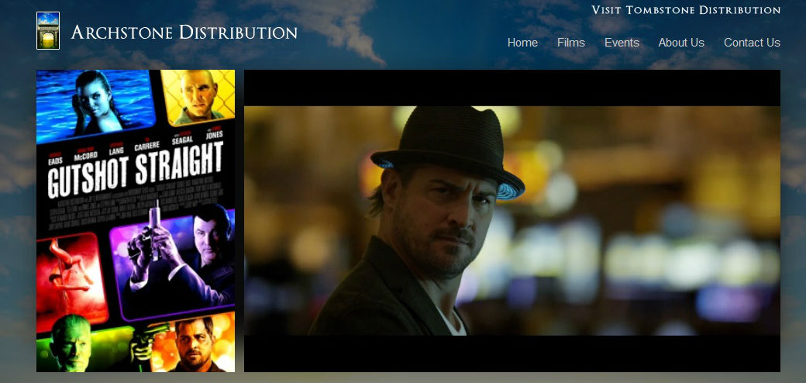

Click to View ‘Gutshot Straight’ Trailer

